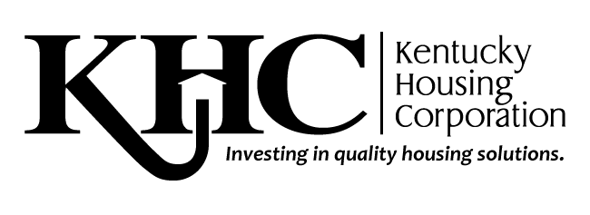

October 5, 2021

To Whom It May Concern:

Kentucky Housing Corporation (KHC) received $85 million in Homeowner Assistance Funds (HAF) from the U.S. Department of the Treasury to prevent mortgage delinquencies, defaults, foreclosures, loss of utilities or home energy services, and the displacement of homeowners experiencing financial hardship after January 21, 2020.

The HAF assistance will not exceed a total of $35,000 per household. KHC will make payments directly to the applicable payees, i.e. servicers, HOAs, insurance companies, tax assessors, etc. This mortgage assistance is not to exceed 6-months of mortgage payments or $35,000 total, whichever amount is reached first.

The Homeowner Assistance Fund provides a non-recourse grant to homeowners and accomplishes two goals:

- Servicers see their foreclosure rates decrease as KHC assumes mortgage payments for up to 6 months.
- Customers receive a grant to provide them with adequate time to recover financially and assume their mortgage payments once again.

If you choose to participate as a servicer with KHC’s Homeowner Assistance Fund, you will receive monthly mortgage payments for eligible customers. To participate, you must set up a payment system, such as Automated Clearing House (ACH) to ensure you receive mortgage payments for loans you service.

We look forward to your partnership with us on this exciting program! If you would like to participate, please email the forms with requested attachments to Miranda Cornish at mcornish@kyhousing.org. If you have questions about the Homeowners Assistance Fund, please contact me toll-free in Kentucky at (800) 633-8896 or (502) 308-3939, extension 219; TTY 771.

Miranda Cornish

Servicing Liaison Administrator

